Experiment 10: Tic Tac Toe Game
Aim
To develop a Tic Tac Toe game using Python.
Objective
To allow two players to play Tic Tac Toe.
Algorithm
- Create the game board.
- Accept player input.
- Update the board.
- Check for a winner.
- Display the result.
Flowchart
Start
|
Create Board
|
Player Move
|
Winner?
/ \
No Yes
| |
Repeat Stop
Code
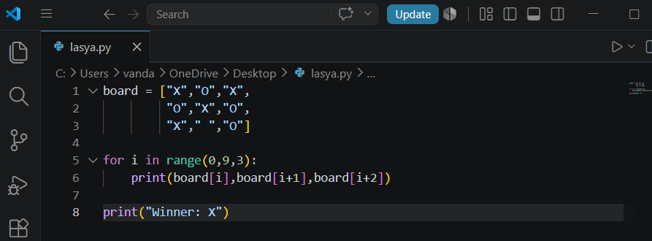
Output:
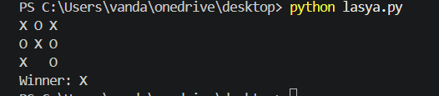
Result
The Tic Tac Toe game executed successfully.
Conclusion
The game correctly displays the board and identifies the winner.

